**Charotar University of Science and Technology**

**Charotar Institute of Paramedical Sciences (CIPS)**

Department of Medical Imaging Technology

Online Workshop on “Image Processing using 3D Slicer”

Department of Medical Imaging Technology organised a 3 days Online Workshop on Image processing using 3D Slicer from 16 July 2020 to 18 July 2020. The Workshop was organised by the department of Medical Imaging Technology in collaboration with Pragrathan Rejuvenating Nature and Jajal Medical Services. Both the Pragrathan and Jajal Medical Services are the emerging companies in the Medical field which deals with the planning and custom manufactures of prosthetics and implants used for Surgery.

The main objectives of the Online workshop were –

* To impart the students and other participants with the knowledge about the application and use of post processing technique – Volume rendering techniques using the 3D Slicer application.
* To introduce the application of 3D printings in the Medical Field.
* To aware students about career and newly emerging job prospects using Image Processing.
* To aware the participants about the future prospects of 3D Image Processing and their application for Implants manufacture.

The details of the programme were compiled in the Flyer along with the link for registration and distributed using Social Media such as what’s app. The registration process was open from date 9th July 2020 to 15th July 2020 and the details of the participants were collected using the Google forms. The total of 249 registration were received and confirmation of registration was sent using the faculty personal email along with download link of the 3D slicer application and required DICOM files. Registration from different University and Institutes were received i.e. R.K. university – Rajkot, Parul University – Vadodara, Symbiosis International University – Pune, SGT University – Gurgaon, NITTE University – Mangalore, Maharishi Markendeshwar University – Haryana, Sharda University – Delhi, RIMT University – Punjab, Quantum University – Uttarakhand, Datta Meghe Institute of Medical Sciences – Maharashtra, Cauvery group of Allied health sciences – Mysore, Himalayan university - Arunachal Pradesh, Assam Downtown University – Assam, Subharti medical college – Meerut, Jamia Hamdard University – Delhi and many others.

The programme was conducted with 2-hour session for 3 days. The topic for the workshop were-

* Day 1 – Introduction of 3D Slicer and its application
* Day 2 – Basic Tools and handling of 3D Slicer
* Day 3 – Image processing on 3D Slicer

Officially the program started at 10:00 AM, 16th July 2020 on Google Platform – Google Meet. Mrs. Dolly Sharma (Department Head – MIT) welcomed the participants and introduced the spokespersons. Immediately after that Mr. Ravi Kant Kamal (Senior Scientist - Jajal Medical Sciences, Vadodara) delivered a detail and very informative talk on the role of Imaging Technologist in 3D post processing and future scope of 3D printing in Medical Field. Mr. Dhaval D. Trivedi (Founder & Director of Pragrathan – Rejuvenating Nature) then started his presentation on Topic “Introduction of 3D Slicer and its application” and concluded the session for the day. On the second day, Mr. Dhaval started his presentation on Basic tools used in 3D slicer and gave the hands-on training, using the 3D slicer. The session lasted for 2 hours and the spokesperson concluded for the second day. On the final day, Mr. Dhaval gave hands-on training for using Image processing using the same software. At the end of the session Mr. Manna Debnath gave the vote of thanks and concluded the session.

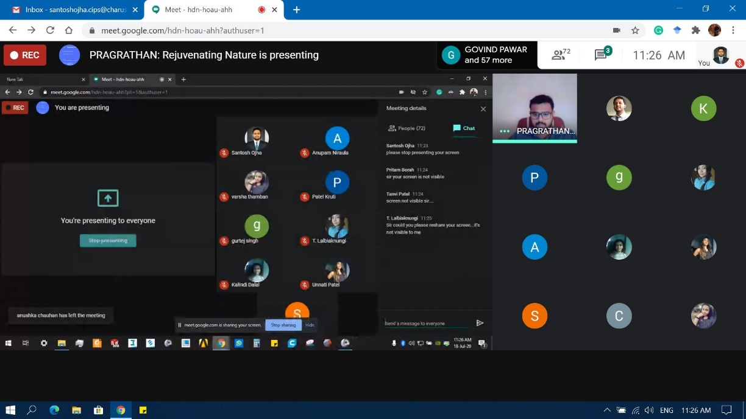The Screen was recorded for all sessions and shared with the participants for future references using the Google drive link. The feedback form was collected from the participants on the final day – a total of 119 responses were collected. The e – certificates were sent to the registered participants by faculty within 2 days after the completion of the Workshop using their institutional Email.

